Signage for C21 North East, 87 Main St. Amesbury:

Exterior details:
Sign: 26 x 38
Style: Flat digital printed with laminate
Posts: Existing on exterior of building
Colors: C21 Branded- Black and muted gold

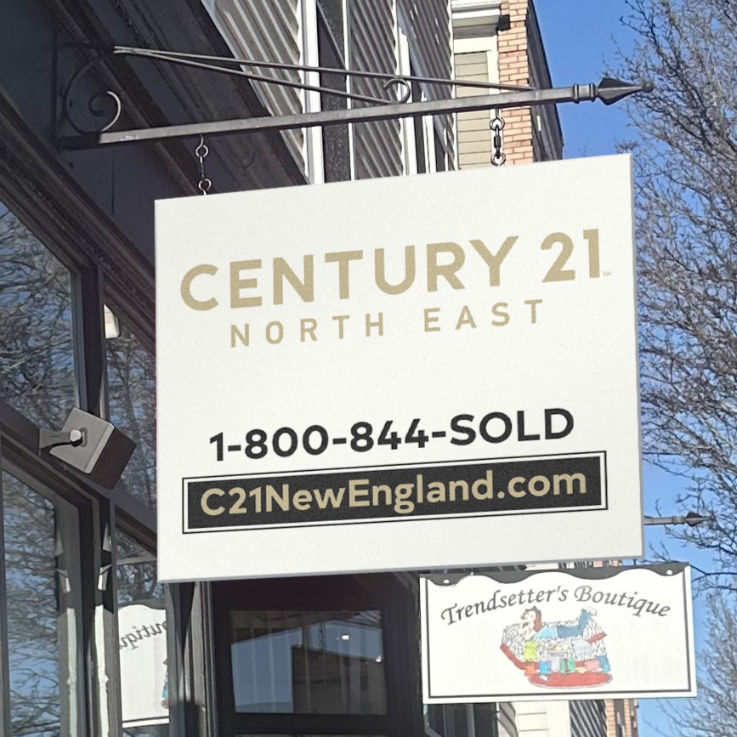

Please review previous pictures and previous application. This sign is similar, only a change in company name. The brackets and lighting are existing and will remain the same

